Use this Template for the DS Assignment

Please note that you can modify this template to suit your own presentation

This is only a sample, you should make sure all aspects of your work and assessment tasks are clearly evidenced

You should also check Assignment Deliverables should in the Assessment guide and the marking schema.

Assessment Details (read the assessment guide for full details)
See Appendix 1 for the Case study. Important note: please note that you need to choose only one of the three options in the Case Study to design, implement and test.

Part one (40%):
- Produce an Entity Relationship Model (ERM) for the selected part of the Case Study requirements. List 4-6 Validation questions for your model. Please use case tool QSEE (or new SEMANTIC Pad) for your data model. [30 Marks]
- Considering and justifying Logical and Physical Design Stage decisions. Produce a brief discussion for your choices. List any changes that you have made to the final physical Model. [10 Marks]
- Forward engineer your final data model (incorporating any decisions made in Task 2) to create tables. Consider carefully declarative constraints for your tables. Insert suitable and well-planned data. Create a view based on your table(s) and write a code to test it. Use SQL Scripts Environment for the whole task. [30 Marks]
- Produce an Application with five SQL Apex Reports based on your validation questions in task 1. Your SQL Apex Reports should be of an intermediate and advanced level. [30 Marks]

Deliverables Part 1
Submit a single compressed file, i.e. zip- not a rar file! The file should include:
Evidence your work using the Assessment TemplatePart1 (found on VLE) include:
  - a document file with your data model (tasks 1-2), tasks 3-4 should include screen shots evidencing your student id and show that the code for the task is working successfully (or not). We expect to see code and data for each table clearly, not just screenshot of ‘no errors’. Where appropriate show evidence of code being tested. e.g. View images.
  - An export of the script with the code for your tables, data and view (DDL, DML and Apex SQL based Reports).

Important note: You must use your own University Oracle Apex account to produce this assignment.

Title:
Student Name:
Student id:

Task 1
Paste here your EERD
(Please make sure that we can see your diagram, easily. Use QSEE to design your EERD)

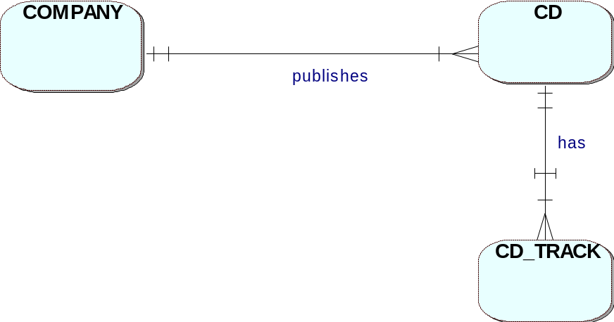

Your Assumptions

List your attributes and identifiers here:
Occurrences for each entity...
Example: Company
COMPANY_ID | COMPANY_NAME | COUNTRY | PHONE_NUMBER
1 | EMI | UK | (0171) 9998812
2 | MCA | UK | 0171 7789088
3 | ISLAND | UK | 0171 0966088
4 | RCA | UK | 0171 1989088

Example: CD
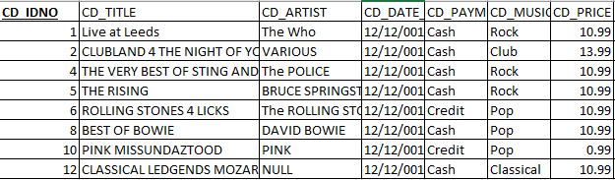

Example: CD_TRACK

TRACK_NO | TRACK_TITLE | TRACK_LENGTH
1 | HEAVEN AND HELL | 4.3
2 | I CAN'T EXPLAIN | 2.16
3 | FORTUNE TELLER | 2.34
1 | IRISH BLUE | 4.3
2 | I CANT LET YOU GO | 4.3
2 | The Cant Stand Losing You | 1.01
3 | Englishman In New York | 2.01
4 | Every Breathe You Take | 4.01
5 | The Walking On The Moon | 4.01
6 | Fields Of Gold | 3.01
7 | If I Ever Lose My Faith In You | 3.01
8 | The Roxanne | 3.01
1 | The Rising | 2.01

1.4 Include a list of the Validation Questions of your model here:
- List of companies in UK
- List all company phone numbers

1.5 A definition for each entity…..
- EntityName: Company hold details on the CD’s publisher
- EntityName:

Task 2
Logical Design (relational data model – derive your tables, pks and fks)
COMPANY (COMPANY_ID, … other attributes
CD (CD_IDNO, ……., COMPANY_ID
CD_TRACK (TRACK_NO, CD_IDNO, other non-key attributes here

Physical Design Considerations
- Consolidating (merging multiple into one) your tables before implementation - discuss why you have/ haven't done it!
- Decomposing (dividing one into multiple) tables before implementation - discuss why you have/ haven't done it!
- PK for each table – change from compound keys to one key attribute (Surrogate Keys?)
- Including derived attributes
- Deal with M:N relationships, if not done at conceptual design stage
Consider constraints on the tables (column or table level)
Etc…

Discuss briefly your changes and why.
This example hasn’t got any super and sub entities to demo consolidation of the tables, nor has it got tales with huge amount of data to show decomposition of the tables. In your assignment you will have an example of a composition (consolidation).

Example: Company table, name is unique constraint added, address is varchar2 data type, CD_Track got surrogate key, ID dependency removed from the ERD.

Final ERD with physical design decisions.

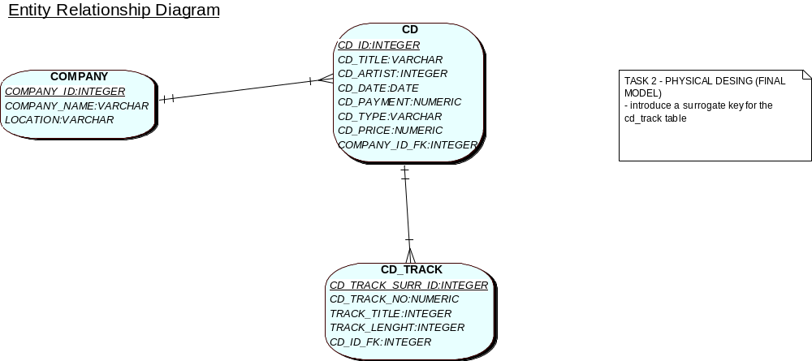

Task 3
Apex Screenshot that table have been successfully created. Include your id in the screen shot!
Show code and successful run of the code. Eg.

Discuss briefly what issue you had with your script,
Eg 1. You had to remove ‘ON DELETE RESTRICT ON UPDATE RESTRICT’ from ALTER TABLE CD ADD CONSTRAINT fk1_CD_to_COMPANY FOREIGN KEY(fk1_COMPANY_ID) REFERENCES COMPANY(COMPANY_ID) ON DELETE RESTRICT ON UPDATE RESTRICT;
Eg. 2 QSEE generated drop table commands without ‘CASCADE CONSTRAINTS’

Successful run of the code, CLEAERLY SHOWING YOUR STUDENT ID. E.g.
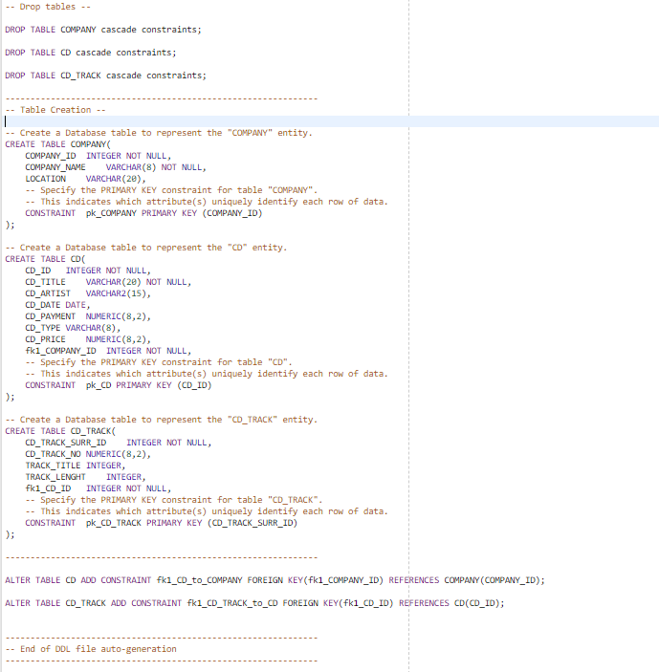
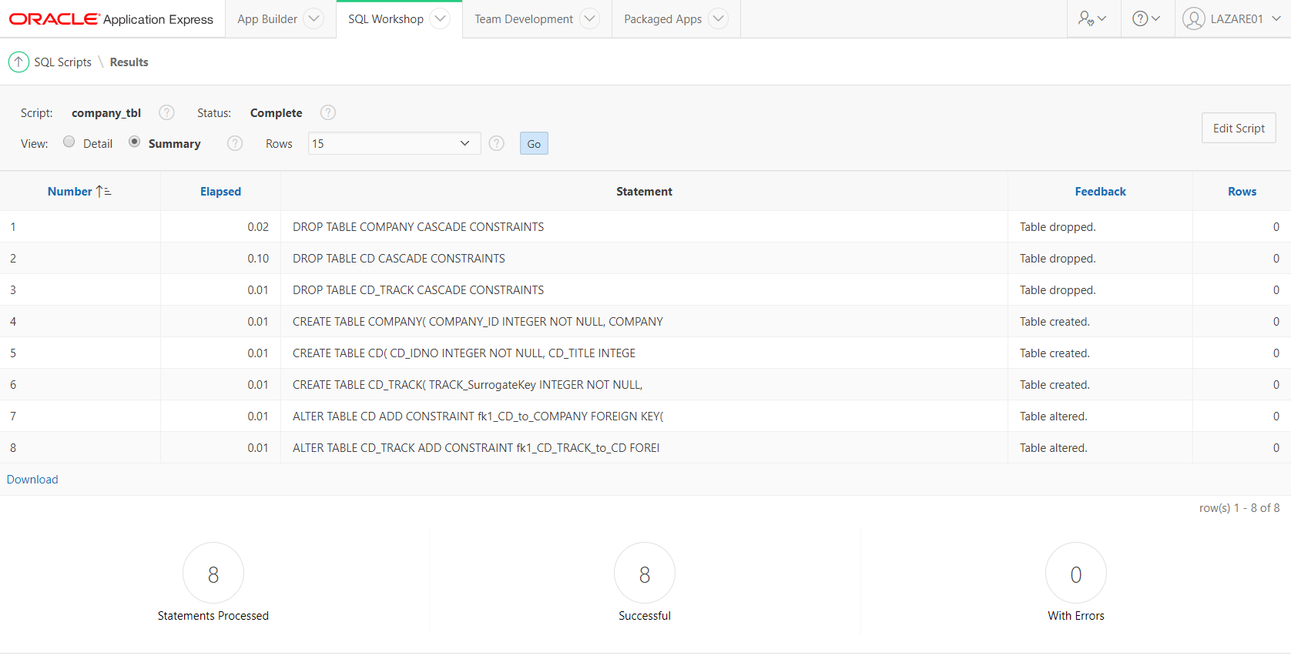

Show code for insert statements working, include your student id in the screenshot
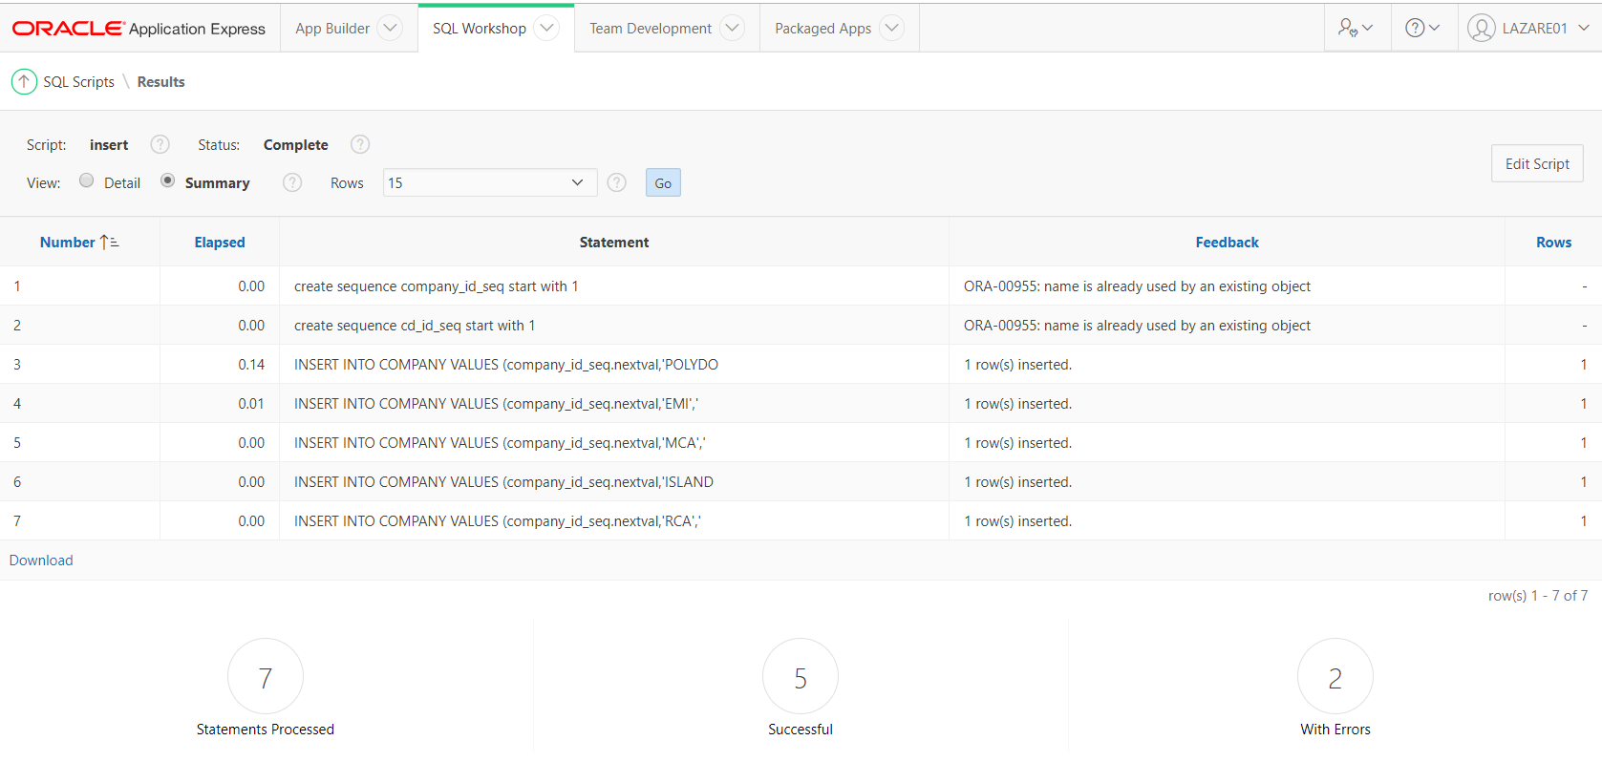

Show view code and successful run of the code. Eg.
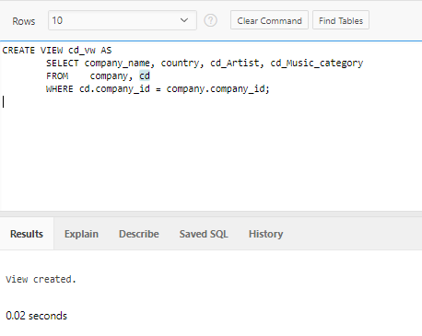

Task 4

Apex Report1: SQL code and Screen shot of the Report
E.G
SELECT COMPANY_NAME, CD_ARTIST FROM CD, COMPANY WHERE CD.COMPANY_ID = COMPANY.COMPANY_ID

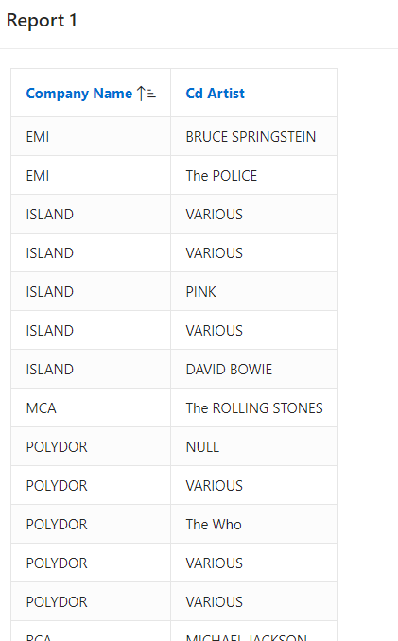

Apex Report2: SQL code and Screen shot of the Report

Apex Report3: SQL code and Screen shot of the Report

Etc….

…

Bibliography

Harvard style

Appendixes
DDL and DML code

